**Creating a Parent Portal Account**

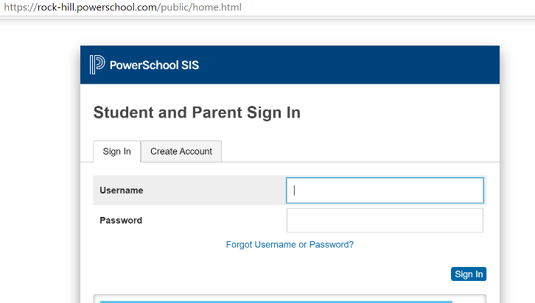**1: Visit** [**https://rock-hill.powerschool.com/public**](https://rock-hill.powerschool.com/public)

**If you previously have had a Parent Portal Account for your**

**student(s), you can enter your username and password.**

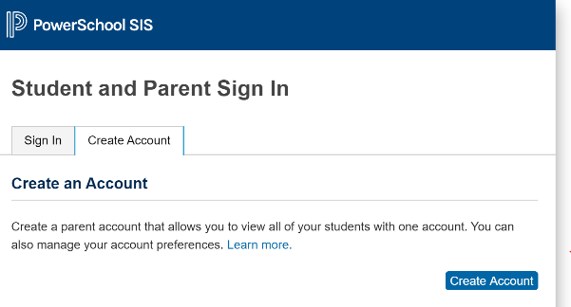**2: If you have never had a Parent Portal account,**

**please click on Create Account**

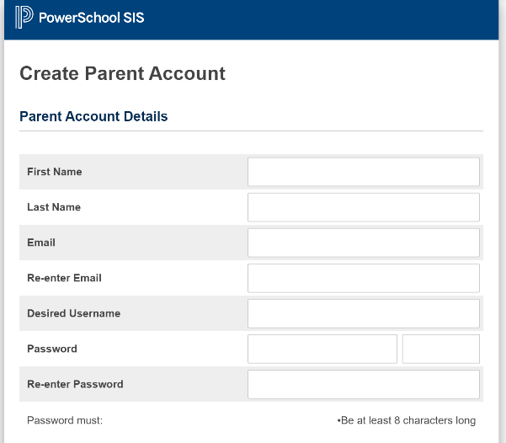

**3: Create your Parent Account**

**Be sure to provide all information, if you have previously created an account with the same email address it will not allow you to create a new one.**

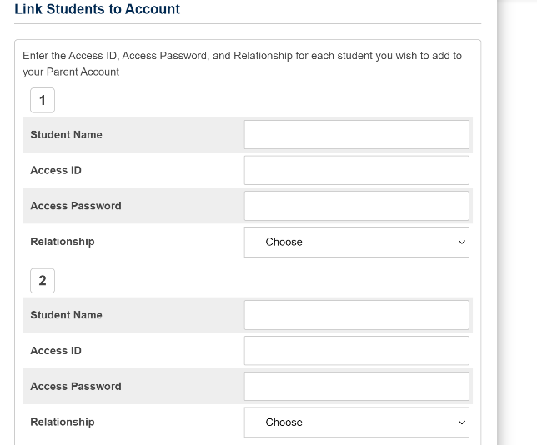**4: Link your student(s) to your account.**

**You will need the following information, their 5 digit access id (student’s lunch #) and their access password (student’s birthday).**

**i.e. Jan 5, 2003 = 01052003**

**Oct 17 2003 = 10172003**

* **You can link multiple students in this step**
* **When entering the password (birthday), sometimes the 5th is entered as 05 and sometimes as 5. You may have to try both.**

**5: A confirmation link will be sent to your email, it takes about 5 minutes to receive. Once you receive it, you can click on the activitation link and it will take you back to the login page.**

**6: Tool Bar on left side will provide options to view: Grades & Attendance, My Schedule, Forms, etc.**

